Pat Reynolds
Deployment 4
Deploying via terraform

Part 1 – Configure Jenkins

- Created EC2 in US-East-1, public subnet with ports 22/8080/80 open
- Added Jenkins key to package manager and information to package manager with wget – then echo deb to dev/null
- Installed Java runtime environment as it’s a requirement for Jenkins
- Installed python 3.10-venv and python3-pip
- Installed Jenkins into EC2, started Jenkins service
- Manage Jenkins – Add Credentials – Added AWS access+secret keys
- Installed terraform onto Jenkins EC2
___________________________________________________________________________________

Part 2 – Creating the pipeline

- Jenkinsfile will work as follows
- Build stage – create virtual environment using python venv and activate it. Use pip to install all dependencies and libraries needed for the application to run(requirement.txt) – then launch Flask application
- Test stage – Inside the virtual environment, an integration test is ran to see if the application API returns a 200(success) response code
- Init – Initalizes the intTerraform directory, setting the aws secret key and access key identifiers from jenkins to variables to be used for terraform.
- Plan – Similar to doing terraform plan it outlines the setup to be created. It also creates a file called plan.tfplan carrying the variables

Issues

- Plan stage failed. Went to check and update my Keys to check if a space was present.
- Jenkins plan stage froze; as well as the UI due to the amount of resources being used on one ec2. Forcing a restart of the ec2.
- Plan stage succeeded after reset but the apply stage effectively hung
- Attempt 3 plan stage took 13 minutes; apply stage failed; restarted instance
- Attempt 4 Apply stage failed due to invalid key in main.tf
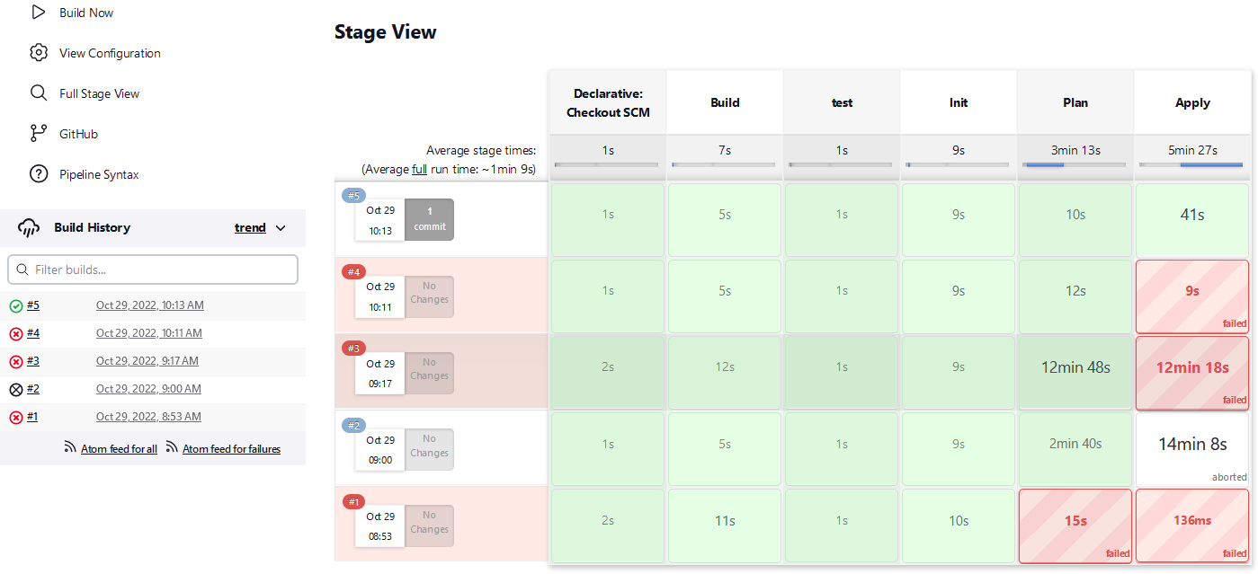

Part 3 – Modification of pipeline

- Destroy stage added to get rid of first apply
- Initially created a VPC in main.tf ; however due to the amount of resources that need to be created, made it have its own file.
- I wanted to add the slack message plugin; and installed that as well to send a message on each step until the Apply stage finished.

Issues

- Broke Jenkinsfile by forgetting to add ) after adding new variables to be carried over
- Did not initialize new variables at top of page; so init stage failed
- Failed to add the security group to VPC; so got that the group and subnet belong to different networks
- I found myself unable to use a module to set up the VPC and security group; since both the module.vpc syntax, and the module.vpc.name.id syntax both failed
- Once the environment was created; I could not get access to the application due to not having a proper routing table or internet gateway.
- I found I needed to use the Keeprunning plugin that was used for the previous deployment or the userscript that ran when the instance was launched would not continue, despite not being a jenkins step.
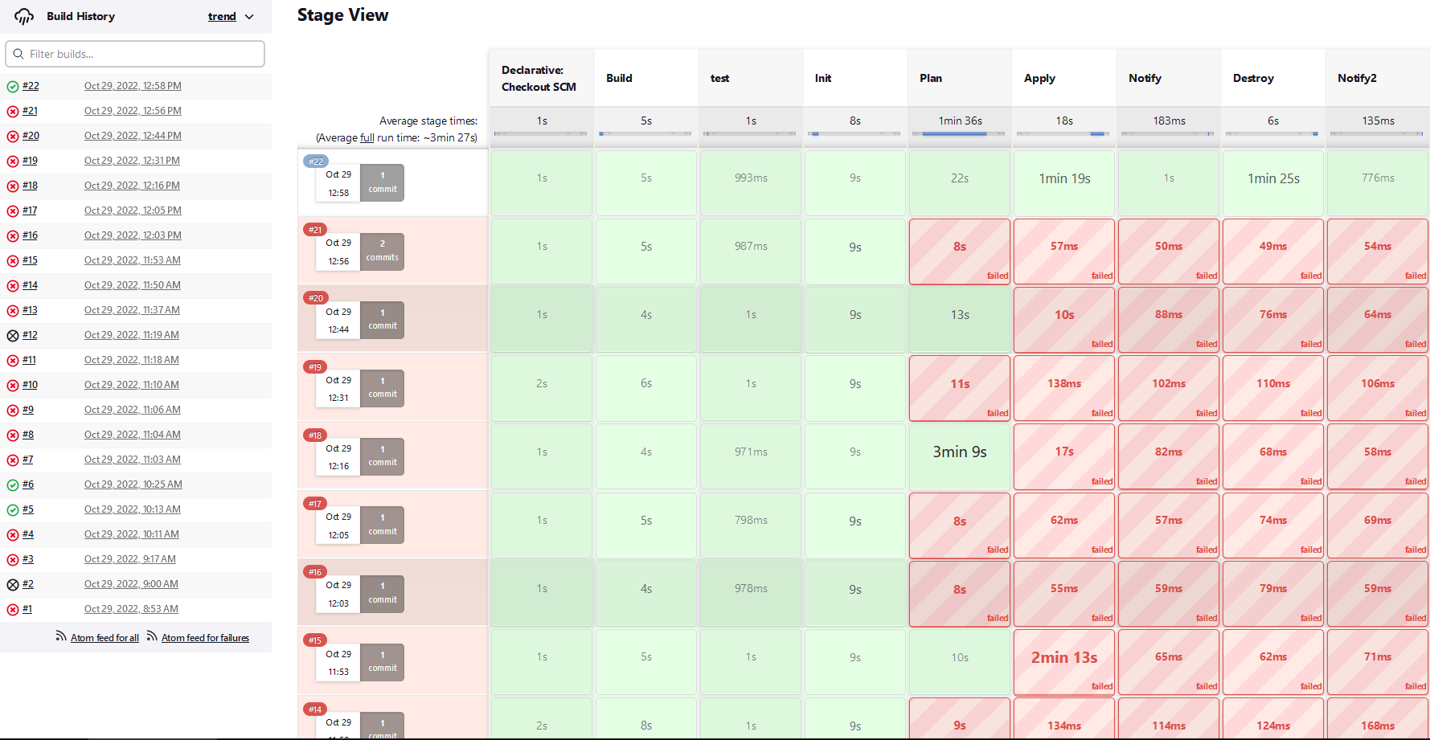

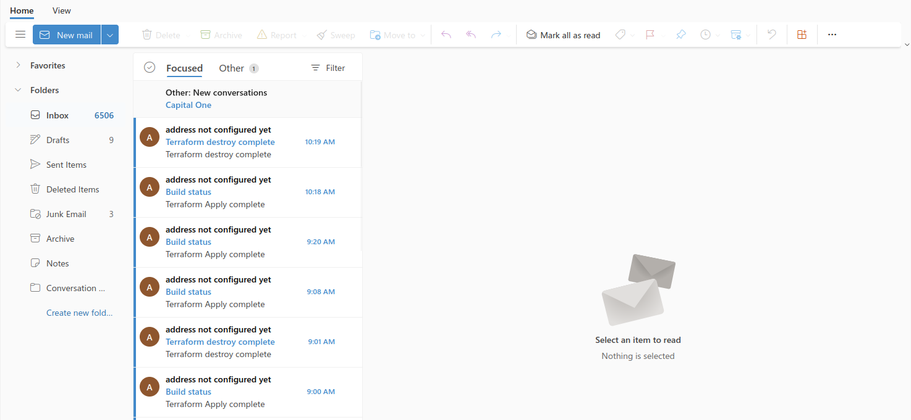

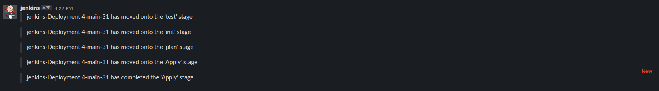

Major takeaways from this deployment

- Resource contention was a major problem in this deployment. Having Jenkins service running with terraform at the same time caused the ec2 instance to outright crash or lock up at times.
- In place of the tfvars file; you can have variables declared in a terraform file and hidden using Jenkins, just you need to import those variables values to terraform’s initialization and other stages
- Email after every step is insanely spammy; having a mix of Slack and Email allows better notification of important steps and allows me to know which steps passed, and failed without looking at the console.
- I forget it enough times; but a VPC that isn’t the default needs more setup to actually communicate to the internet. A full configuration requires the vpc resource with cidr – a subnet, an internet gateway to access the internet, and a routing table to be linked to subnets.

Improvements to be made

- In a real scenario; I would need multiple availability zones for my deployed infrastructure for redundancy and availability.
- Similarly, I would need to move my application to a private subnet to ensure it stays more secure.
- Still need to add a pylint or more forms of testing to check for vulnerabilities, or to make code cleaner if the application was a larger file.
- For organizing my VPC files; I definitely need practice building them and working more with Terraform, for now what I did was okay but when more modules, more resources start being created it might get a little hard to manage without organizing parts into local module folders.
- Perhaps learn to utilize remote modules for this exercise in the future.

